# Answer in Brief

# What is Process Synchronization with its four conditions in details

# A process is an active program i.e a program that is under execution. It is more than the program code as it includes the program counter, process stack, registers, program code etc.

# Process States

# 

# New - The process is in the new state when it has just been created.

# • Ready - The process is waiting to be assigned the processor by the shortterm scheduler.

# • Running - The process instructions are being executed by the processor.

# • Waiting - The process is waiting for some event such as I/O to occur.

# • Terminated - The process has completed its execution.

# Draw and Explain Distributed Architecture of file System

# 

# 

# 

# Explain Shared Memory with implementation of Algorithm

# 

# 

# 

# 

# 

# 

# 

# Explain Deadlocks with its Strategy in details

# 

# 

# Explain necessary conditions for Deadlock with diagram

# 

# Explain Distributed Operating system with its types

**Distributed Operating Systems**

Distributed systems require a network to connect all of its elements (devices, hardware, or software) so that they may exchange messages and interact.

A distributed system's ability to consistently convey messages, whether they're delivered, received, acknowledged, or how a node retries after a failure, is a key aspect.

Services and applications required to scale, and additional computers necessary to be added and managed, therefore distributed systems were born.

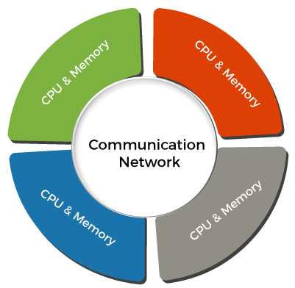

It connects multiple computers via a single communication channel. Furthermore, each of these systems has its own processor and memory.

Types of Distributed Operating System

1. **Client-Server Systems**
2. **Peer-to-Peer Systems**
3. **Middleware**
4. **Three-tier**
5. **N-tier**

### Client-Server System

This type of system requires the client to request a resource, after which the server gives the requested resource. When a client connects to a server, the server may serve multiple clients at the same time.

Client-Server Systems are also referred to as "Tightly Coupled Operating Systems".

Client-Server Systems function as a centralized server since they approve all requests issued by client systems.

**Server systems can be divided into two parts:**

1. **Computer Server System**

This system allows the interface, and the client then sends its own requests to be executed as an action. After completing the activity, it sends a back response and transfers the result to the client.

1. **File Server System**

It provides a file system interface for clients, allowing them to execute actions like file creation, updating, deletion, and more.

### Peer-to-Peer System

The nodes play an important role in this system. The task is evenly distributed among the nodes. Additionally, these nodes can share data and resources as needed. Once again, they require a network to connect.

The Peer-to-Peer System is known as a "Loosely Couple System".

This concept is used in computer network applications since they contain a large number of processors that do not share memory or clocks.

### Middleware

Middleware enables the interoperability of all applications running on different operating systems. Those programs are capable of transferring all data to one other by using these services.

### Three-tier

The information about the client is saved in the intermediate tier rather than in the client, which simplifies development. This type of architecture is most commonly used in online applications.

### N-tier

When a server or application has to transmit requests to other enterprise services on the network, n-tier systems are used.

# Explain Strategy of Handling Deadlock with example

# 

# 

# Explain Distributed shared Memory in Brief

# Answer in One Sentence

# What is Mutual Exclusion

# 

# Define Process States

# Define Process: A process is an active program i.e a program that is under execution. It is more than the program code as it includes the program counter, process stack, registers, program code etc.

# What is Co-operative process

# Cooperating processes Execution of one process affects the execution of the other. Thus, it is necessary that these processes are synchronized in order to guarantee the order of execution.

# What is independent process

# Independent process is the process that can not affect or be affected by the other processes. Independent processes does not share any data like temporary or persistent with any other process.

# What is race condition in operating system

# 

# What is deadlock in operating System

# A Deadlock is a situation where each of the computer process waits for a resource which is being assigned to some another process. In this situation, none of the process gets executed since the resource it needs, is held by some other process which is also waiting for some other resource to be released.

# What is Distributed File System

# 

# What are the two types of Processes

# 

# What is critical section in operating system

# 

# What is bounded waiting condition in synchronization

# 

# MCQs

# When several processes access the same data concurrently and the outcome of the execution depend on the particular order in which the access take place is called ______

# If a process is executing in it critical section then no other processes can be executing in critical section what is process called ______

# Which process can be affected by the other processes executing in the system is called _______

# Mutual Exclusion can be provided by the ___________

# Process Synchronization can be done on __________

# Client- Server system is also known as ______________

# The Peer-to- Peer system is known as ______________

# Agreement is always required to achieve a ____________ goal in distributed System

# Memory Mapping manager is responsible for mapping between Local Memory and Shared Memory Address Space